**PRACTICAL NUMBER 7**

AIM :

1. Write a program with dart to display message "welcome to the world of dart programming".

**CODE :**

void main() {

print("welcome to the world of dart programming");

print("I'm using DartPad Online compiler.");

}

**OUTPUT :**

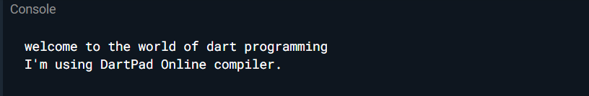

**2**) Write a dart program to create a variable and display the value of it.

**CODE :**

void main(){

final a=12;

const pi=3.14;

print(a);

print(pi);

}

**OUTPUT :**

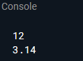

**3)** Write a dart program to create a list and display it.

**CODE :**

void main(){

var list=[1,2,3,4,5];

print(list);

}

**OUTPUT :**

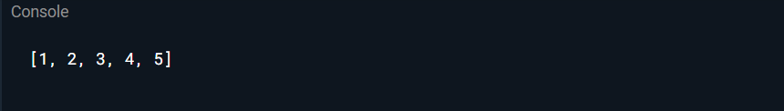

**4)** Write a dart program to create a map and display it.

**CODE :**

void main(){

var mapping={'id':1,'name':'Dart'};

print(mapping);

}

**OUTPUT :**

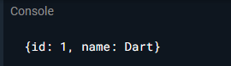

**5)** Write a dart program to print number which is divided by 2 from 1 to 10.

**CODE :**

void main(){

for(var i=1;i<=10;i++){

if(i%2==0){

print(i);

}

}

}

**OUTPUT :**

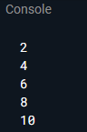

**6**) Write a dart program to create function to add two values and print it.

**CODE** :

// Arithmetic Operation

void main(){

add(100,50);

}

void add(int a,int b){

int c, d, e, g;

c = a+b;

print("The Addition of $a and $b is : $c");

d = a-b;

print("The Subtraction of $a and $b is : $d");

e = a*b;

print("The Multiplication of $a and $b is : $e");

double f;

f = a/b;

print("The Division of $a and $b is : $f");

g = a%b;

print("Modulus : $g");

}

**OUTPUT :**

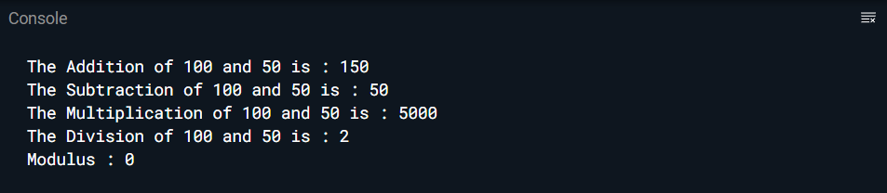

// Relational operators OR Comparison operators

**CODE :**

void main() {

int a = 10;

int b = 5;

bool isEqual = a==b;

print('Is $a equal to $b : $isEqual');

bool isNotEqual = a!=b;

print('Is $a not equal to $b : $isNotEqual');

bool isGreaterThan = a>b;

print('$a is greater than $b : $isGreaterThan');

bool isLessThan = a<b;

print('$a is less than $b : $isLessThan');

bool isGreaterOrEqual = a>=b;

print('$a is greater than or equal to $b : $isGreaterOrEqual');

bool isLessOrEqual = a<=b;

print('$a is less than or equal to $b : $isLessOrEqual');

}

**OUTPUT :**

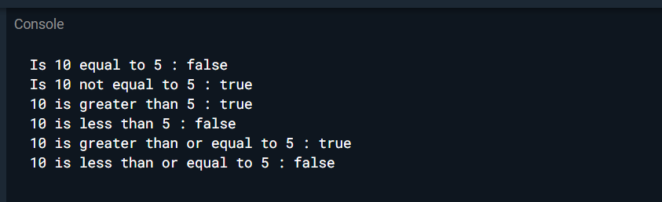

**7)** Write a dart program to create to implement getter and setter with the class.

**CODE :**

class Employee {

String name = "";

//getting method

String get emp_name {

return name;

}

//setter method

void set emp_name(String name) {

this.name = name;

}

//function definition

void result() {

print(name);

}

}

void main() {

//object creation

Employee emp = new Employee();

emp.name = "employee1";

emp.result(); //function call

}

**OUTPUT :**

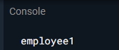

**8)**Write a dart program to implement single level inheritance.

**CODE :**

class Bird{

void fly()

{

print("The bird can fly");

}

}

class Parot extends Bird{

void speak(){

print("The Parot can speak");

}

}

void main(){

Parot p=new Parot();

p.speak();

p.fly();

}

**OUTPUT :**

